Guide Dog Tour – Lets Go Walking

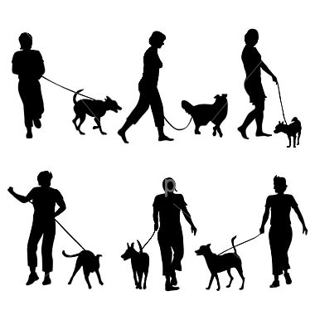

To understand what a guide dog has to go through to become qualified, they must learn to judge widths and height of objects which helps it to avoid dangerous obstacles such as overhanging branches and signs. It is taught to avoid bumping into objects like people, prams, and bicycles. It is not the dog that makes the decision about when to cross the road. In general, the owner knows whether traffic is moving, or whether cars have stopped.

The owner then gives the “forward” command to the dog to cross the road. If the owner has not heard the approach of a vehicle, the dog will refuse the command, then proceed once the car has passed. Before training with a guide dog, the owner is well oriented to the area and able to direct the dog to the destination. Having 1raveled the route a number of times, the dog will remember the route. There are many cases where guide dog users have reported that their dogs have remembered a particular doorway or house, even when they have not visited the place for twelve months.

This activity asks you to imagine that you are a guide dog walking through a park. You will be working in pairs.
One partner draws a map of a park with a starting point and finishing point. The other partner simulates a guide dog going through the park by drawing a line from where they travelled from point A to Point B. Use a spot on line to show where a dog may stop writing for further instruction from their owner.

MAP

KEY

 Other animals
 Bicycles
 Traffic

 People

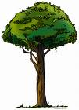 Trees

© 2007 Association for the Blind of Western Australia
Exceptions: Images
© Microsoft Office Clip Art 2007

